**Aim**: Implement Two-dimensional Translation on Rectangle.

#include<iostream.h>

#include<graphics.h>

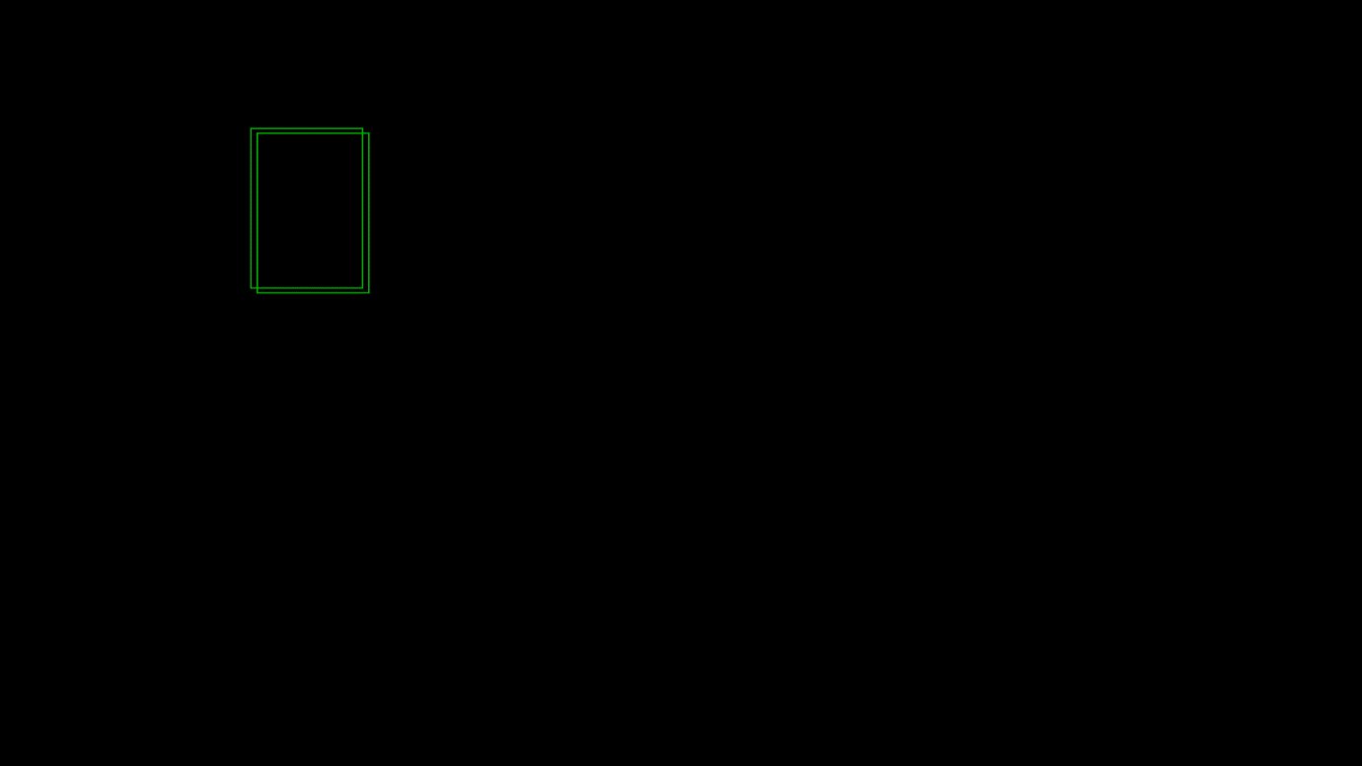#include<conio.h>

void translateRectangle ( int P[][2], int T[])

{

int gd = DETECT, gm, errorcode;

initgraph (&gd, &gm, "c:\\turboc3\\bgi");

setcolor (2);

rectangle (P[0][0], P[0][1], P[1][0], P[1][1]);

// calculating translated coordinates

P[0][0] = P[0][0] + T[0];

P[0][1] = P[0][1] + T[1];

P[1][0] = P[1][0] + T[0];

P[1][1] = P[1][1] + T[1];

rectangle (P[0][0], P[0][1], P[1][0], P[1][1]);

}

void main()

{

int P[2][2] = {50, 80, 120, 180};

int T[] = {4, 3};

translateRectangle (P, T);

getch();

}